Designs:
Original
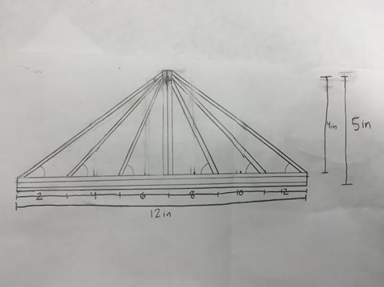
Modified: 18 in. x 24 in.
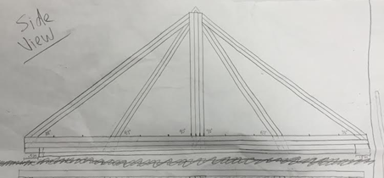
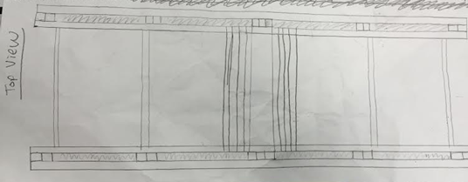
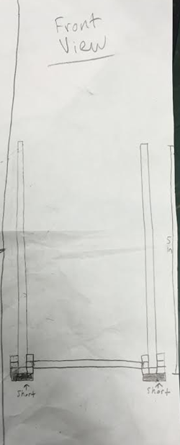
Design Expectations:
Our design, first of all, met each of the requirements. Other than this, our design was purposed to distribute the support when the block applies a force. When the block pushes down on the middle of the roadway, the force will be redistributed throughout our base, which we decided to reinforce with multiple layers of wood (three to four). The force would then be distributed to the vertical supports, which are, similarly to the base, reinforced with more layers of wood. However, while the vertical supports make an impact on distribution of force, the bridge will begin to cave in, which is why we added horizontal beams between our tuffs—to keep the bridge from collapsing inwards. The kingpost tuffs serve to distribute the tension and force, supporting the bridge overall. We have six kingpost tuffs on each side of the bridge (three on the left, three on the right), each doubled up with wood layers, once again to reinforce the tuffs and create more ability to withstand tension and force.

Designing the bridge:
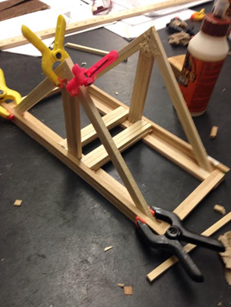
Our original design, we realized, was not nearly sturdy enough. To combat this issue, we continued to add reinforcement beams and more trusses to give our bridge more support, resulting in the following:
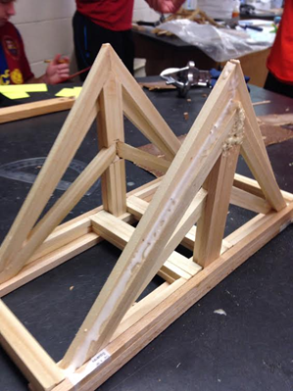
We discovered that our road did not meet the requirements, being one level too high above the base of support, so we had to find a way to fix the issue.
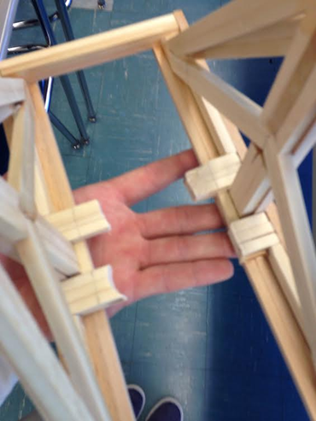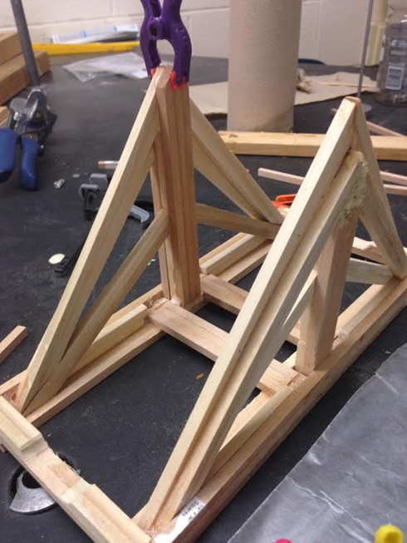
After fixing the road, we added the horizontal beams to keep the bridge from collapsing inward, resulting in our final bridge:
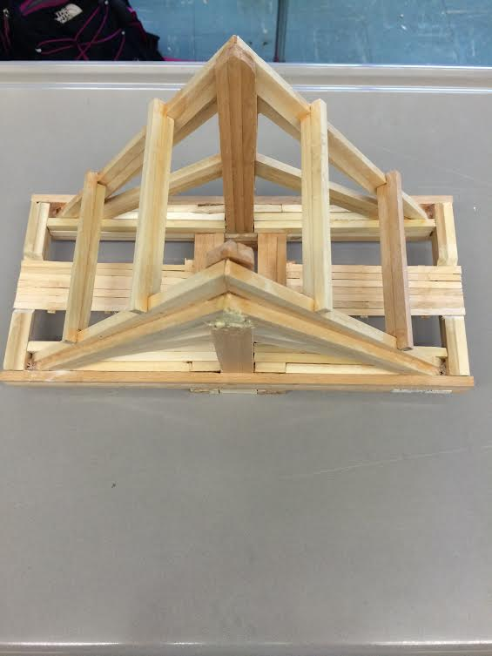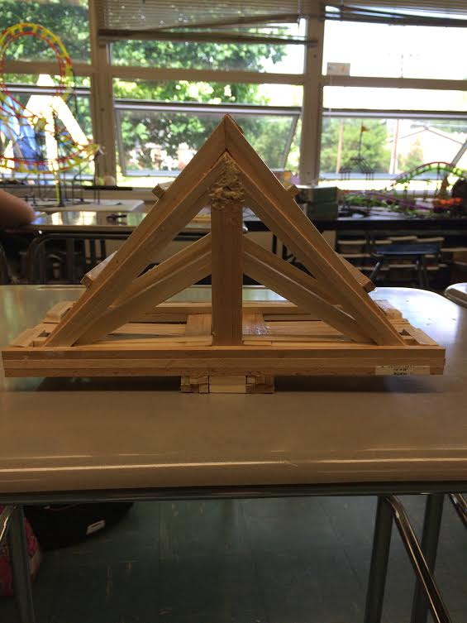

Performance:
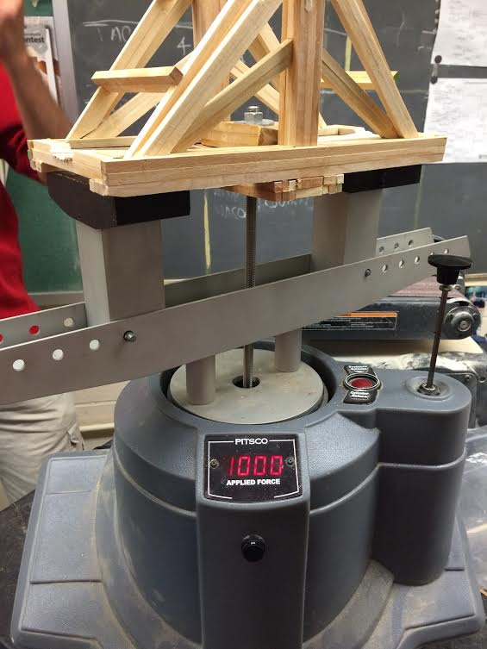
Our bridge weighed a total of 487 grams at the end. When testing, our bridge easily held 1,000 (+) pounds of force, bending only .2 centimeters (2 millimeters). We are uncertain of the total strength factor because our bridge did not break, but at the point the test concluded, the strength factor of our bridge was 2.05 (?). The stiffness of our bridge was 10.27 (?).

Our bridge performed extremely well. Each of our design parameters fulfilled its duty: Our sturdy road, base, trusses, and supports, each reinforced with multiple layers of wood, distributed the force evenly, so the bridge did not bend and collapse in the middle. Our horizontal wooden planks also did its job: keeping the bridge from collapsing inwards. The major stress on our bridge was on the base at the road, where the bridge slightly bent about 2 millimeters. Because we had to conclude the testing before our bridge broke, it is hard to determine where exactly we could have improved our bridge (we had no initial breaking point to reference). However, we could have double-layered the trusses to give the bridge more support and strength. On the other hand, we could have used less material at the base to produce a better support:weight ratio, making a more efficient bridge.

Our ratio of support to weight is not exact (due, again, to our test being concluded before the bridge broke), but it is this:

2.053 pounds : 1 gram

